New from box tops for education
BUY BOX TOPS PRODUCTS. Look for the logo.
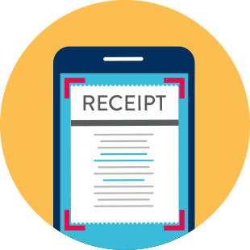SCAN YOUR RECEIPT with the Box tops app.
Tap the scan button and snap a photo of your receipt within 14 days of purchase.
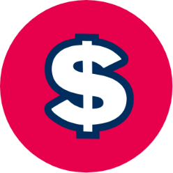EARN CASH FOR Drexel School
It's that easy! Box Tops earnings are identified and automatically updated online.

Some items continue to have the old Box Tops clip; those will have to be clipped and brought to the school.
